SQL ASSIGNMENT – CLASSICMODELS DATASET

1. List all customers who live in the USA.

#Approach 1
select * from customers
where country='USA';

#Approach 2 - using subqueries
select * from customers
where country in ('USA');

Explanation:
Approach 1:
This query directly filters the customers table using the WHERE clause to return only rows where the country is 'USA'.
It is simple, efficient, and best suited when checking for a single specific value.
Approach 2:
This query uses the IN operator (a subquery-style condition) to match the country against a list containing 'USA'.
It is useful when filtering by multiple possible values and makes the query easier to expand later.
Output:
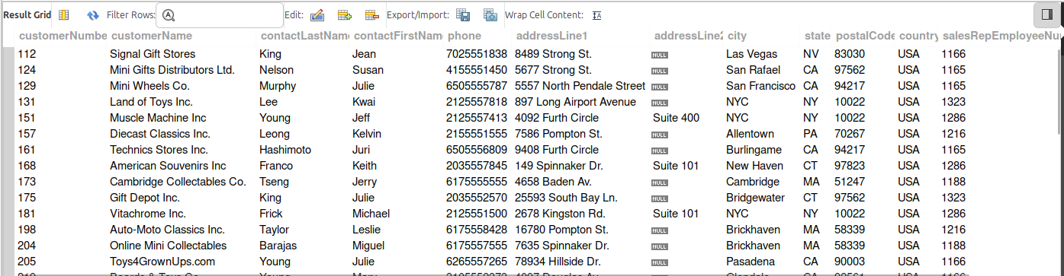

2.Show the total number of orders for each product line.

#Approach 1 - Using Joins
SELECT p.productLine, COUNT(o.orderNumber) AS total_orders
FROM products p
JOIN orderdetails od ON p.productCode = od.productCode
JOIN orders o ON od.orderNumber = o.orderNumber
GROUP BY p.productLine;

#Approach 2 - Using Subqueries
SELECT productLine,
(SELECT COUNT(*)
FROM orderdetails od
JOIN products pr ON od.productCode = pr.productCode
WHERE pr.productLine = p.productLine) AS total_orders
FROM products p
GROUP BY productLine;

Explanation:
Approach 1 (Using Joins):
This query joins products, orderdetails, and orders tables to relate product lines with their orders.
It groups the results by productLine and counts the number of associated orders.
Approach 2 (Using Subqueries):
This query uses a correlated subquery to count orders for each productLine separately.
For every product line in the outer query, the subquery calculates the total matching orders.
Output:

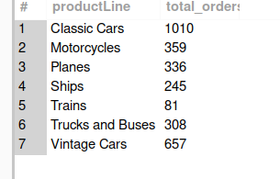

3.Display the name and job title of each employee.

#Approach 1
select concat(firstName," ",lastName) Full_Name,jobTitle Job_Title
from employees;
#Approach 2
select firstName,lastName,jobTitle from employees;

Explanation:
Approach 1:
This query combines firstName and lastName using CONCAT to display the full name in a single column.
It also renames the columns using aliases for better readability.
Approach 2:
This query selects firstName, lastName, and jobTitle as separate columns.
It keeps the structure simple without combining or renaming fields.
Output:

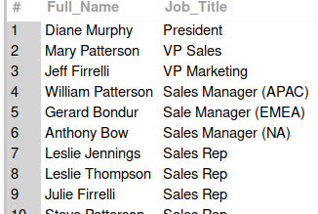

4.Count the number of products with a price higher than the average price.

#Approach 1

SELECT COUNT(*) as PriceHighAvg
FROM products
WHERE buyPrice > (SELECT AVG(buyPrice) FROM products);

#Approach 2
SELECT COUNT(*) as PriceHighAvg
FROM products p
JOIN (
SELECT AVG(buyPrice) AS avg_price
FROM products
) a
ON p.buyPrice > a.avg_price;

Explanation:
Approach 1:
This query uses a subquery to calculate the average buyPrice from the products table.
It then counts products whose price is greater than that calculated average.
Approach 2:
This query calculates the average price in a derived table and joins it with products.
It filters products by comparing their price with the computed average value.

Output:

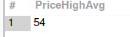

5.List the top 5 customers by the number of orders.

select c.customerName,count(o.orderNumber) as TotalOrders
from customers c
join orders o
on c.customerNumber = o.customerNumber
group by c.customerName
order by TotalOrders desc
limit 5;

#Approach 2
select * from (
select c.customerName , count(o.orderNumber)
from customers c
join orders o
on c.customerNumber=o.customerNumber
group by c.customerName
order by count(o.orderNumber)desc) as k
limit 5;

Explanation:
Approach 1:
This query joins customers and orders, groups by customer name, and counts total orders.
It sorts the results in descending order and limits the output to the top 5 customers.
Approach 2:
This query first calculates order counts inside a subquery and sorts them.
The outer query then limits the result to the top 5 customers.
Output:

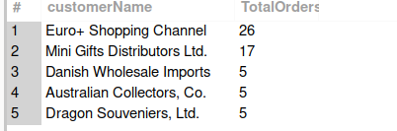

6.Show all offices and their respective country and city.

#Approach 1
select officeCode,country,city
from offices;

#Approach 2
SELECT officeCode,
CONCAT(city, ', ', country) AS location
FROM offices;

Explanation:

Approach 1:
This query directly selects officeCode, country, and city from the offices table.
It displays each column separately without modification.
Approach 2:
This query combines city and country into a single column using CONCAT.
It provides a formatted location output while still showing the officeCode.
Output:
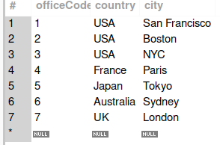

7.Find the lowest and highest credit limits among all customers.

#Approach 2
select min(creditLimit) as Lowest_Credit,max(creditLimit) as Highest_Credit
from customers;

#Approach 2
(SELECT creditLimit AS lowest_credit
FROM customers
ORDER BY creditLimit ASC
LIMIT 1)

UNION

(SELECT creditLimit AS highest_credit
FROM customers
ORDER BY creditLimit DESC
LIMIT 1);

Explanation:
Approach 1 (Using MIN & MAX):
This query uses aggregate functions MIN() and MAX() to directly get the lowest and highest credit limits.
It is efficient and returns both values in a single row.
Approach 2 (Using ORDER BY & UNION):
This query sorts credit limits in ascending and descending order to fetch the lowest and highest values separately.
It combines both results using UNION to display them together.
Output:

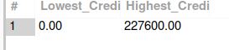

8.Display the details of the last 5 payments.

#Approach 1
select * from payments
order by paymentDate desc
limit 5;

#Approach 2
SELECT p.*
FROM payments p
JOIN (
SELECT paymentDate
FROM payments
ORDER BY paymentDate DESC
LIMIT 5
) t ON p.paymentDate = t.paymentDate
order by paymentDate desc;

Explanation:
Approach 1:
This query orders payments by paymentDate in descending order.
It limits the result to the most recent 5 records.
Approach 2:
This query first selects the latest 5 payment dates in a subquery.
It then joins back to the payments table to retrieve full details.
Output:

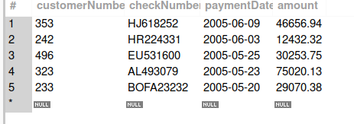

9.Count the number of employees in each job title.

#Approach 1
select distinct jobTitle,count(employeeNumber) as Total_Emp
from employees
group by jobTitle
order by Total_Emp;

#Approach 2:
select e1.jobTitle,
(select count(*) from employees e2
where e2.jobTitle=e1.jobTitle;

Explanation:
Approach 1:
This query groups employees by jobTitle and counts employees in each group.
It orders the results based on the total employee count.
Approach 2:
This query uses a correlated subquery to count employees for each job title.
For every job title in the outer query, the subquery calculates the total count.
Output:
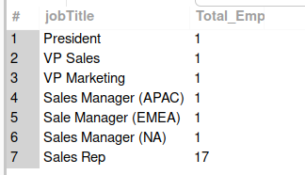

10.List the names of products with a scale of 1:10.

#Approach 1
select productName from products
where productScale="1:10";

#Approach 2
select productName from products
where productScale like "1:10";

Explanation:
Approach 1:
This query filters products where productScale exactly equals "1:10".
It returns only matching product names.
Approach 2:
This query uses the LIKE operator to match the scale "1:10".
It works similarly but is more useful when pattern matching is needed.
Output:

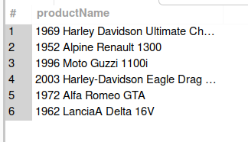

11. Calculate the total quantity of products ordered for each order.

#Approach 1
select orderNumber,sum(quantityOrdered) as TotalQty
from orderdetails
group by orderNumber;

#Approach 2
select od1.orderNumber,(select sum(od2.quantityOrdered) from
orderdetails od2
where od1.orderNumber=od2.OrderNumber)
as total_quantiy
from orderdetails od1;

Explanation:
Approach 1:
This query groups orderdetails by orderNumber and sums quantityOrdered.
It gives the total quantity per order.
Approach 2:
This query uses a correlated subquery to calculate total quantity for each order.
For every order in the outer query, the inner query computes the sum.
Output:

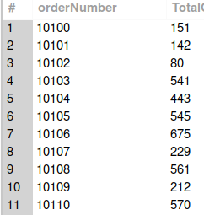

12. Show the customer who has placed the largest number of orders.

#Approach 1
select c.customerName,count(o.orderNumber) as Tota_Orders from
customers c
join orders o
on c.customerNumber=o.customerNumber
group by c.customerName
order by count(o.orderNumber) desc
limit 1;

#Approach 2
SELECT c.customerNumber,
c.customerName,
COUNT(*) AS total_orders
FROM customers c
JOIN orders o
ON c.customerNumber = o.customerNumber
GROUP BY c.customerNumber, c.customerName
HAVING COUNT(*) = (
SELECT MAX(order_count)
FROM (
SELECT COUNT(*) AS order_count
FROM orders
GROUP BY customerNumber
) t
);

Explanation:
Approach 1:
This query joins customers and orders, groups by customer name, and counts total orders.
It sorts in descending order and limits the result to the top customer.
Approach 2:
This query calculates order counts per customer and compares them with the maximum order count using a subquery.
It returns the customer(s) whose order count equals the highest value.
Output:

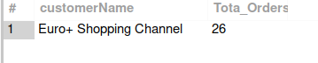
13.List the employees and the total sales amount for each

#Approach 1
select concat(e.firstName," ",lastName) as Employee_Name,sum(od.priceEach*od.quantityOrdered) as Total_Sales
from employees e join customers c
on e.employeeNumber=c.salesRepEmployeeNumber
join
orders o
on c.customerNumber=o.customerNumber
join
orderdetails od
on od.orderNumber=o.orderNumber
group by concat(e.firstName," ",lastName);

#Approach 2
SELECT e.employeeNumber,
CONCAT(e.firstName, ' ', e.lastName) AS employee_name,
(
SELECT SUM(od.quantityOrdered * od.priceEach)
FROM customers c
JOIN orders o ON c.customerNumber = o.customerNumber
JOIN orderdetails od ON o.orderNumber = od.orderNumber
WHERE c.salesRepEmployeeNumber = e.employeeNumber
) AS total_sales
FROM employees e;
Explanation:
Approach 1:
This query joins employees, customers, orders, and orderdetails to calculate total sales per employee.
It groups by employee name and sums sales amount.
Approach 2:
This query uses a correlated subquery to calculate total sales for each employee.
For every employee in the outer query, the subquery computes their total sales.
Output:

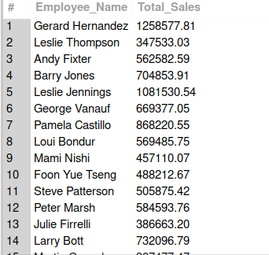

14. Display the products and the total amount of stock for each product line.

#Approach 1
select productLine,sum(quantityInStock) as TotalStock
from products
group by productLine;

#Approach 2
Select distinct p1.productLine,
(select sum(p2.quantityInStock) from products p2
where p1.productLine=p2.productLine) as total_stock
from products p1;

Explanation:
Approach 1:
This query groups products by productLine and sums quantityInStock.
It shows total stock available per product line.
Approach 2:
This query uses a correlated subquery to calculate stock for each product line.
For each distinct product line, it computes the total quantity in stock.
Output:

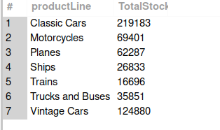

15.Find the average order size for each customer.

Approach 1
SELECT customerNumber,
AVG(order_total) AS avg_order_size
FROM (
SELECT o.customerNumber,
o.orderNumber,
SUM(od.quantityOrdered * od.priceEach) AS order_total
FROM orders o
JOIN orderdetails od ON o.orderNumber = od.orderNumber
GROUP BY o.orderNumber, o.customerNumber
) t
GROUP BY customerNumber;

Approach 2
SELECT customerNumber,
AVG(order_total) AS avg_order_size
FROM (
SELECT o.customerNumber,
o.orderNumber,
SUM(od.quantityOrdered * od.priceEach) AS order_total
FROM orders o
JOIN orderdetails od ON o.orderNumber = od.orderNumber
GROUP BY o.orderNumber, o.customerNumber
) t
GROUP BY customerNumber;

Explanation:
Approach 1:
This query first calculates total amount per order in a subquery.
Then it computes the average order value per customer from those totals.
Approach 2:
This approach is identical to Approach 1, using a derived table to calculate order totals.
It then groups by customer to calculate the average order size.
Output:

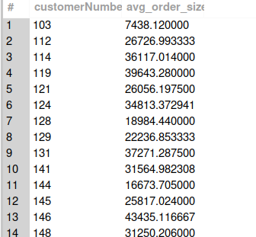

16. Show the top 10 orders by total order amount.

#Approach 1
select orderNumber,sum(quantityOrdered * priceEach) as totalOrderAmt
from orderdetails
group by orderNumber
order by totalOrderAmt desc
limit 10;
#Approach 2
SELECT *
FROM (
SELECT orderNumber,
SUM(quantityOrdered * priceEach) AS totalOrderAmt
FROM orderdetails
GROUP BY orderNumber
) t
ORDER BY totalOrderAmt DESC
LIMIT 10;

Explanation:
Approach 1:
This query calculates total order amount using SUM(quantityOrdered * priceEach).
It orders results in descending order and limits to top 10.
Approach 2:
This query first calculates total order amount in a subquery.
The outer query sorts the results and limits them to the top 10.
Output:

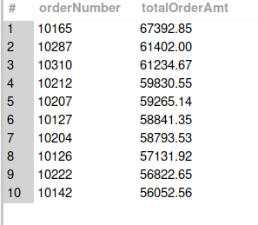

17. List customers who have made payments totaling over $100,000.

select * from payments limit 10;

#Approach 1
select c.customerNumber as Customer_Number,c.customerName as Customer_Name,sum(p.amount) as total_payment
from customers c join payments p
on c.customerNumber=p.customerNumber
group by Customer_Number,Customer_Name
having total_payment>100000;

#Approach 2
SELECT customerNumber,
SUM(amount) AS total_payments
FROM payments
GROUP BY customerNumber
HAVING SUM(amount) > 100000;

Explanation:
Approach 1:
This query joins customers and payments, groups by customer, and sums payment amounts.
It filters customers whose total payments exceed 100,000 using HAVING.
Approach 2:
This query directly groups payments by customer and calculates total payments.
It uses HAVING to filter customers with payments greater than 100,000.
Output:

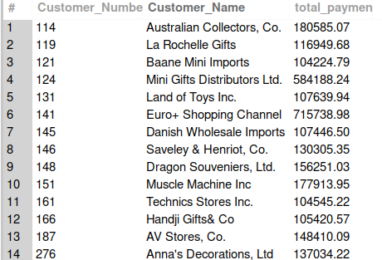

18. Display product lines and total number of products in each line.

#Approach 1
select productLine, count(productName) as Total_Products
from products
group by productLine;

Approach 2
SELECT DISTINCT p1.productLine,
(
SELECT COUNT(*)
FROM products p2
WHERE p2.productLine = p1.productLine
) AS total_products
FROM products p1;

Explanation:
Approach 1:
This query groups products by productLine and counts product names.
It shows total number of products in each line.
Approach 2:
This query uses a correlated subquery to count products for each product line.
It selects distinct product lines and calculates their product counts.
Output:

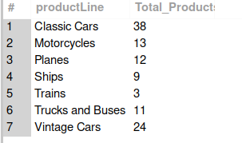

19. Show the month and year with the highest number of orders.

#Approach 1
select year(orderDate) as y,month(orderDate) as m,count(orderNumber) Total_Orders
from orders
group by y ,m
order by Total_Orders desc
limit 1;

#Approach 2
SELECT year, month, total_orders
FROM (
SELECT YEAR(orderDate) AS year,
MONTH(orderDate) AS month,
COUNT(*) AS total_orders
FROM orders
GROUP BY YEAR(orderDate), MONTH(orderDate)
) t
WHERE total_orders = (
SELECT MAX(order_count)
FROM (
SELECT COUNT(*) AS order_count
FROM orders
GROUP BY YEAR(orderDate), MONTH(orderDate)
) x
);

Explanation:
Approach 1:
This query groups orders by year and month and counts total orders.
It sorts in descending order and limits to the highest value.
Approach 2:
This query calculates order counts per month and year in a subquery.
It selects the record(s) where total orders equal the maximum order count.
Output:

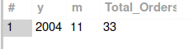

20. Find the average time between consecutive payments for each customer.

#Approach 1
SELECT customerNumber,
ROUND(AVG(days_between), 2) AS avg_days_between_payments
FROM (
SELECT customerNumber,
DATEDIFF(
paymentDate,
LAG(paymentDate) OVER (
PARTITION BY customerNumber
ORDER BY paymentDate
)
) AS days_between
FROM payments
) t
WHERE days_between IS NOT NULL
GROUP BY customerNumber;

#Approach 2
SELECT p1.customerNumber,
ROUND(AVG(DATEDIFF(p1.paymentDate, p2.paymentDate)), 2)
AS avg_days_between_payments
FROM payments p1
JOIN payments p2
ON p1.customerNumber = p2.customerNumber
AND p2.paymentDate = (
SELECT MAX(p3.paymentDate)
FROM payments p3
WHERE p3.customerNumber = p1.customerNumber
AND p3.paymentDate < p1.paymentDate
)
GROUP BY p1.customerNumber;

Explanation:
Approach 1:
This query uses the LAG() window function to calculate days between consecutive payments.
It then averages those differences per customer.
Approach 2:
This query joins the payments table to itself to find the previous payment date.
It calculates the date difference and averages it for each customer.
Output:

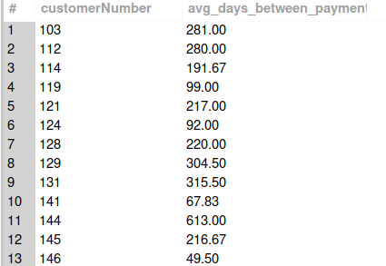

21. Rank customers based on the frequency of their orders.

#Approach 1
SELECT customerNumber,
COUNT(*) AS total_orders,
RANK() OVER (ORDER BY COUNT(*) DESC) AS order_rank
FROM orders
GROUP BY customerNumber;

#Approach 2
SELECT customerNumber,
COUNT(*) AS total_orders,
DENSE_RANK() OVER (ORDER BY COUNT(*) DESC) AS order_rank
FROM orders
GROUP BY customerNumber;

Explanation:
Approach 1 (Using RANK):
This query counts total orders per customer and applies the RANK() function.
Customers with equal order counts receive the same rank, with gaps in ranking.
Approach 2 (Using DENSE_RANK):
This query also counts orders per customer but uses DENSE_RANK().
Customers with equal order counts share the same rank without gaps in ranking.
Output:

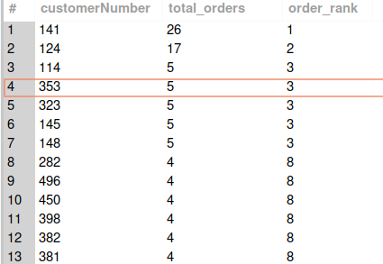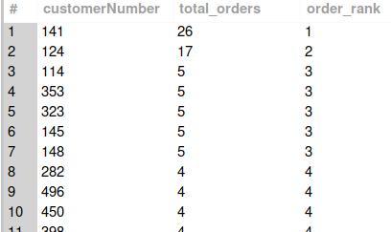

22.Using a CTE, calculate total sales for each employee per year.

#Approach 1
with CTE_total_sales as
(select e.employeeNumber,year(o.orderDate) order_year,sum(od.priceEach*od.quantityOrdered) sales_per_year
from employees e
join
customers c
on e.employeeNumber=c.salesRepEmployeeNumber
join
orders o
on c.customerNumber =o.customerNumber
join orderdetails od
on o.orderNumber=od.OrderNumber

group by e.employeeNumber ,year(o.orderDate))

select * from CTE_total_sales
order by employeeNumber,order_year;

#Approach 2
SELECT e.employeeNumber,
YEAR(o.orderDate) AS order_year,
SUM(od.quantityOrdered * od.priceEach) AS total_sales
FROM employees e
JOIN customers c
ON e.employeeNumber = c.salesRepEmployeeNumber
JOIN orders o
ON c.customerNumber = o.customerNumber
JOIN orderdetails od
ON o.orderNumber = od.orderNumber
GROUP BY e.employeeNumber, YEAR(o.orderDate)
ORDER BY e.employeeNumber, order_year;

Explanation:
Approach 1 (Using CTE):
This query calculates yearly sales per employee inside a CTE and then selects from it.
It improves readability by separating aggregation logic from the final result.
Approach 2 (Without CTE):
This query directly performs joins and aggregation in a single statement.
It groups by employee and year to calculate total sales.
Output:

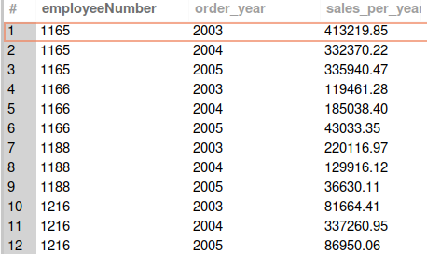

23.Show year-over-year change in average order size.

WITH yearly_avg AS (
SELECT YEAR(orderDate) AS order_year,
AVG(order_total) AS avg_order_size
FROM (
SELECT o.orderNumber,
o.orderDate,
SUM(od.quantityOrdered * od.priceEach) AS order_total
FROM orders o
JOIN orderdetails od
ON o.orderNumber = od.orderNumber
GROUP BY o.orderNumber, o.orderDate
) t
GROUP BY YEAR(orderDate)
)
SELECT order_year,
avg_order_size,
avg_order_size - LAG(avg_order_size)
OVER (ORDER BY order_year) AS yoy_change
FROM yearly_avg;

#approach 2
WITH yearly_avg AS (
SELECT YEAR(o.orderDate) AS order_year,
AVG(order_total) AS avg_order_size
FROM (
SELECT o.orderNumber,
o.orderDate,
SUM(od.quantityOrdered * od.priceEach) AS order_total
FROM orders o
JOIN orderdetails od
ON o.orderNumber = od.orderNumber
GROUP BY o.orderNumber, o.orderDate
) t
GROUP BY YEAR(orderDate)
)
SELECT y1.order_year,
y1.avg_order_size,
y1.avg_order_size - y2.avg_order_size AS yoy_change
FROM yearly_avg y1
LEFT JOIN yearly_avg y2
ON y1.order_year = y2.order_year + 1;

Explanation:
Approach 1 (Using LAG):
This query calculates yearly average order size and uses LAG() to compare it with the previous year.
It directly computes the YoY difference using a window function.
Approach 2 (Self Join):
This query joins the yearly average table with itself to compare consecutive years.
It subtracts the previous year’s value to get YoY change.

Output:

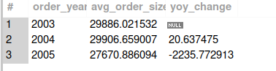

24.Products never included in any order

#Approach 1
select p.productName from
products p
left join orderdetails od
on p.productCode=od.productCode
where od.productCode is null;
#Approach 2
select productCode,productName
from products p
where not exists
(select *
from orderdetails od
where od.productCode=p.productCode);

Explanation:
Approach 1 (LEFT JOIN):
This query uses a LEFT JOIN between products and orderdetails.
Products with no matching order records are identified using NULL values.
Approach 2 (NOT EXISTS):
This query checks for products where no matching order exists using NOT EXISTS.
It is efficient for filtering unmatched records.

Output:

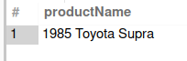

25.Display the total sales amount for each product line per quarter.

select p.productLine,year(o.orderDate) as y,quarter(o.orderDate) as q,sum(od.quantityOrdered*od.priceEach) as Quarter_Sales
from products p
join orderdetails od
on p.productCode=od.productCode
join orders o
on od.orderNumber=o.orderNumber
group by p.productLine,y,q;

#Approach 2
SELECT *
FROM (
SELECT p.productLine,
YEAR(o.orderDate) AS year,
QUARTER(o.orderDate) AS quarter,
SUM(od.quantityOrdered * od.priceEach) AS total_sales
FROM products p
JOIN orderdetails od
ON p.productCode = od.productCode
JOIN orders o
ON od.orderNumber = o.orderNumber
GROUP BY p.productLine, YEAR(o.orderDate), QUARTER(o.orderDate)
) t
ORDER BY year, quarter, productLine;

Explanation:
Approach 1:
This query groups by product line, year, and quarter to calculate quarterly sales.
It directly aggregates total sales using joins.
Approach 2:
This query calculates quarterly totals inside a subquery.
The outer query orders the results for better presentation.
Output:

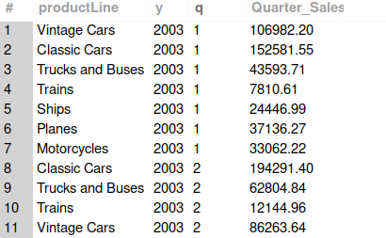

26. Rank employees based on the number of different customers they serve.

#Approach 1
select e.firstName,e.lastName,c.salesRepEmployeeNumber as Employee_Id,count(c.customerNumber) as Customer_Id,
dense_rank() over(order by count(c.customerNumber) desc) as Emp_Rank
from customers c
join
employees e
on c.salesRepEmployeeNumber=e.employeeNumber
group by c.salesRepEmployeeNumber;

#Appproach 2
SELECT t.employeeNumber,
t.total_customers,
(
SELECT COUNT(DISTINCT t2.employeeNumber)
FROM (
SELECT employeeNumber,
COUNT(DISTINCT customerNumber) AS total_customers
FROM customers
GROUP BY employeeNumber
) t2
WHERE t2.total_customers > t.total_customers
) + 1 AS emp_rank
FROM (
SELECT employeeNumber,
COUNT(DISTINCT customerNumber) AS total_customers
FROM customers
GROUP BY employeeNumber
) t;

Explanation:
Approach 1 (Using DENSE_RANK):
This query counts customers per employee and ranks them using DENSE_RANK().
Employees with equal counts share the same rank without gaps.
Approach 2 (Using Subquery Ranking Logic):
This query calculates rank manually by counting employees with higher totals.
It assigns rank based on the number of employees exceeding each total.

Output:

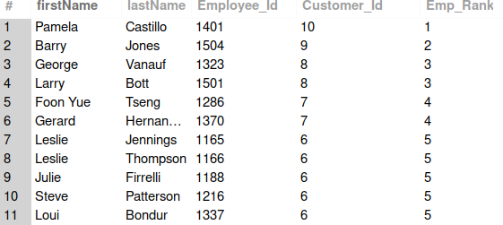

27.Using window functions, calculate the running total of orders per product line.

#Approach 1
SELECT productLine,
orderDate,
SUM(order_count) OVER (
PARTITION BY productLine
ORDER BY orderDate
ROWS BETWEEN UNBOUNDED PRECEDING AND CURRENT ROW
) AS running_total
FROM (
SELECT p.productLine,
o.orderDate,
COUNT(*) AS order_count
FROM products p
JOIN orderdetails od
ON p.productCode = od.productCode
JOIN orders o
ON od.orderNumber = o.orderNumber
GROUP BY p.productLine, o.orderDate
) t;

#Approach 2- Using CTE

WITH product_orders AS (
SELECT p.productLine,
o.orderDate,
COUNT(*) AS daily_orders
FROM products p
JOIN orderdetails od
ON p.productCode = od.productCode
JOIN orders o
ON od.orderNumber = o.orderNumber
GROUP BY p.productLine, o.orderDate
)
SELECT productLine,
orderDate,
SUM(daily_orders) OVER (
PARTITION BY productLine
ORDER BY orderDate
) AS running_total
FROM product_orders
ORDER BY productLine, orderDate;

Explanation:
Approach 1:
This query calculates daily order counts and applies a running total using SUM() OVER.
It partitions results by product line and orders by date.
Approach 2 (Using CTE):
This query first stores daily order counts in a CTE.
It then calculates running totals using a window function.
Output:

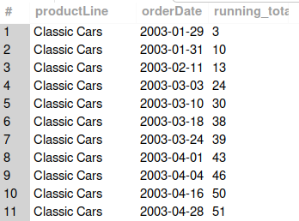

28.Find the product line with the most diverse range of product scales.

#Approach1
select productLine,count(distinct productScale) as total_product_sales
from products
group by productLine
order by total_product_sales desc
limit 1;

#Approach2

SELECT productLine,
COUNT(DISTINCT productScale) AS scale_count
FROM products
GROUP BY productLine
HAVING COUNT(DISTINCT productScale) = (
SELECT MAX(scale_count)
FROM (
SELECT COUNT(DISTINCT productScale) AS scale_count
FROM products
GROUP BY productLine
) t
);

Explanation:
Approach 1:
This query counts distinct product scales per product line.
It orders results descending and limits to the highest value.
Approach 2:
This query calculates distinct scale counts and compares them to the maximum count using a subquery.
It returns the product line(s) with the highest diversity.
Output:


29.Show the office with the highest average employee sales.

WITH emp_sales AS (
SELECT e.officeCode,
e.employeeNumber,
SUM(od.quantityOrdered * od.priceEach) AS total_sales
FROM employees e
JOIN customers c
ON e.employeeNumber = c.salesRepEmployeeNumber
JOIN orders o
ON c.customerNumber = o.customerNumber
JOIN orderdetails od
ON o.orderNumber = od.orderNumber
GROUP BY e.officeCode, e.employeeNumber
)
SELECT officeCode,
AVG(total_sales) AS avg_employee_sales
FROM emp_sales
GROUP BY officeCode
ORDER BY avg_employee_sales DESC
LIMIT 1;

#Approach 2
SELECT officeCode,
AVG(total_sales) AS avg_employee_sales
FROM (
SELECT e.officeCode,
e.employeeNumber,
SUM(od.quantityOrdered * od.priceEach) AS total_sales
FROM employees e
JOIN customers c
ON e.employeeNumber = c.salesRepEmployeeNumber
JOIN orders o
ON c.customerNumber = o.customerNumber
JOIN orderdetails od
ON o.orderNumber = od.orderNumber
GROUP BY e.officeCode, e.employeeNumber
) t
GROUP BY officeCode
ORDER BY avg_employee_sales DESC
LIMIT 1;

Explanation:
Approach 1 (Using CTE):
This query calculates total sales per employee in a CTE.
It then computes average sales per office and selects the highest.
Approach 2 (Using Derived Table):
This query performs the same logic inside a subquery.
The outer query groups by office and finds the highest average.
Output:
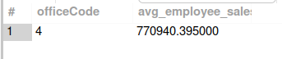

30.YOY growth in the total payments received

#Approach 1
with CTE_year_payments as (
select year(paymentDate) as y,sum(amount) as total_pay
from payments
group by y)
select y ,total_pay-lag(total_pay) over(order by y) as YoY_growth
from CTE_year_payments;

#Approach 2

with CTE_year_payments as (
select year(paymentDate) as y,sum(amount) as total_pay
from payments
group by y)
select y,total_pay,round((total_pay-lag(total_pay)over(order by y))/lag(total_pay)over(order by y)*100,2) as YoY_growth_per
from CTE_year_payments;

Explanation:
Approach 1:
This query calculates yearly total payments and uses LAG() to find absolute YoY growth.
It shows the difference between consecutive years.
Approach 2:
This query calculates percentage YoY growth using the previous year’s value.
It expresses growth as a percentage change.
Output:

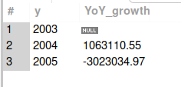

31.Identify the quarter with the highest growth in sales each year.

select year(o.orderDate) y,quarter(o.orderDate) q,sum(od.quantityOrdered*od.priceEach) as Total_Sales
from orders o
join orderdetails od
on o.orderNumber=od.orderNumber
group by y,q;

SELECT y, q, total_sales
FROM (
SELECT
YEAR(o.orderDate) AS y,
QUARTER(o.orderDate) AS q,
SUM(od.quantityOrdered * od.priceEach) AS total_sales,
MAX(SUM(od.quantityOrdered * od.priceEach))
OVER (PARTITION BY YEAR(o.orderDate)) AS max_year_sales
FROM orders o
JOIN orderdetails od
ON o.orderNumber = od.orderNumber
GROUP BY y, q
) t
WHERE total_sales = max_year_sales
ORDER BY y;

#Approach 2
SELECT y, q, total_sales
FROM (
SELECT
YEAR(o.orderDate) AS y,
QUARTER(o.orderDate) AS q,
SUM(od.quantityOrdered * od.priceEach) AS total_sales,
ROW_NUMBER() OVER (
PARTITION BY YEAR(o.orderDate)
ORDER BY SUM(od.quantityOrdered * od.priceEach) DESC
) AS rn
FROM orders o
JOIN orderdetails od
ON o.orderNumber = od.orderNumber
GROUP BY y, q
) t
WHERE rn = 1
ORDER BY y;

Explanation:
Approach 1 (Using MAX Window Function):
This query calculates quarterly sales and finds the maximum per year using a window function.
It filters rows matching the highest quarterly sales.
Approach 2 (Using ROW_NUMBER):
This query ranks quarters per year based on total sales.
It selects the top-ranked quarter for each year.
Output:

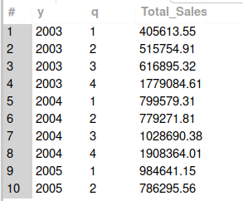

32.Using a CTE, rank the product lines based on their total sales amount.

# Approach 1 -- Using Rank
with CTE_Total_Sales as(
select p.productLine Product_Line,sum(od.priceEach * od.quantityOrdered) as TotalSales
from products p
join orderdetails od
on p.productCode=od.productCode
group by p.productLine)

select Product_Line,TotalSales,rank()
over(order by TotalSales desc) as Ranking_By_Sales
from CTE_Total_Sales;

#Approach 2-- Using Dense_Rank
with CTE_Total_Sales as(
select p.productLine Product_Line,sum(od.priceEach * od.quantityOrdered) as TotalSales
from products p
join orderdetails od
on p.productCode=od.productCode
group by p.productLine)

select Product_Line,TotalSales,rank()
over(order by TotalSales desc) as Ranking_By_Sales
from CTE_Total_Sales;

Explanation:
Approach 1 (Using RANK):
This query calculates total sales per product line in a CTE.
It ranks them using RANK(), allowing gaps in ranking for ties.
Approach 2 (Using DENSE_RANK):
This query uses DENSE_RANK() instead of RANK().
It assigns consecutive ranks without gaps for ties.
Output:
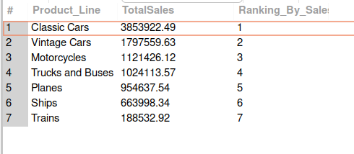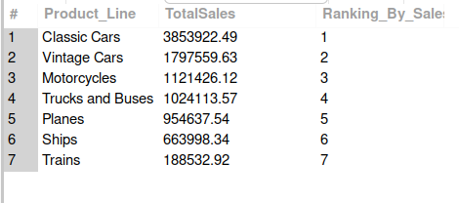

33.Find the average duration between order placement and shipment for each customer.

#Approach 1 -- using CTE
with CTE_diff as(
select c.customerNumber as Customer_Num,c.customerName as Customer_Name,datediff(o.ShippedDate,o.orderDate) as gap
from customers c
join
orders o
on c.customerNumber=o.customerNumber)
select Customer_Num,Customer_Name,avg(gap) as Average_gap
from CTE_diff
group by Customer_Num,Customer_Name;

#Approach 2
SELECT c.customerNumber,
c.customerName,
AVG(DATEDIFF(o.shippedDate, o.orderDate)) AS Average_gap
FROM customers c
JOIN orders o
ON c.customerNumber = o.customerNumber
WHERE o.shippedDate IS NOT NULL
GROUP BY c.customerNumber, c.customerName;

Explanation:
Approach 1 (Using CTE):
This query calculates date differences in a CTE.
It then averages the gap per customer.
Approach 2:
This query directly calculates the average date difference using DATEDIFF().
It filters out orders that haven’t been shipped.
Output:

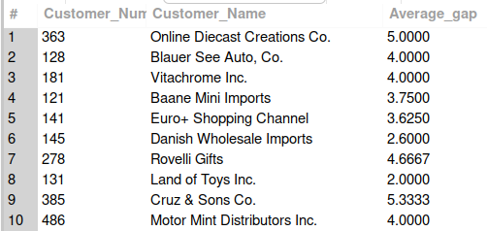

34.List the customers and their least frequently ordered product line.

SELECT i.Cust_Num,
i.Cust_Name,
i.Prod_Line,
i.Product_line_count
FROM (
SELECT c.customerNumber AS Cust_Num,
c.customerName AS Cust_Name,
p.productLine AS Prod_Line,
COUNT(*) AS Product_line_count
FROM customers c
JOIN orders o ON c.customerNumber = o.customerNumber
JOIN orderdetails od ON od.orderNumber = o.orderNumber
JOIN products p ON p.productCode = od.productCode
GROUP BY c.customerNumber, c.customerName, p.productLine
) i
WHERE i.Product_line_count = (
SELECT MIN(Product_line_count)
FROM (
SELECT COUNT(*) AS Product_line_count
FROM orders o
JOIN orderdetails od ON od.orderNumber = o.orderNumber
JOIN products p ON p.productCode = od.productCode
WHERE o.customerNumber = i.Cust_Num
GROUP BY p.productLine
) x
);

#Approach 2 -- using rank

SELECT Cust_Num,
Cust_Name,
Prod_Line,
Product_line_count
FROM (
SELECT c.customerNumber AS Cust_Num,
c.customerName AS Cust_Name,
p.productLine AS Prod_Line,
COUNT(*) AS Product_line_count,
ROW_NUMBER() OVER (
PARTITION BY c.customerNumber
ORDER BY COUNT(*) ASC
) AS rn
FROM customers c
JOIN orders o ON c.customerNumber = o.customerNumber
JOIN orderdetails od ON od.orderNumber = o.orderNumber
JOIN products p ON p.productCode = od.productCode
GROUP BY c.customerNumber, c.customerName, p.productLine
) t
WHERE rn = 1;

Explanation:
Approach 1:
This query calculates order counts per product line per customer.
It selects the minimum count using a correlated subquery.
Approach 2 (Using ROW_NUMBER):
This query ranks product lines per customer in ascending order of frequency.
It selects the least frequently ordered product line using ROW_NUMBER().
Output:

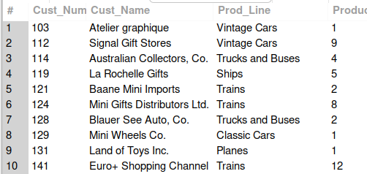

35.Show the total number of orders for each month and compare it to the previous year.

SELECT
YEAR(orderDate) AS y,
MONTH(orderDate) AS m,
COUNT(*) AS total_orders,
COUNT(*) - LAG(COUNT(*)) OVER (
PARTITION BY MONTH(orderDate)
ORDER BY YEAR(orderDate)
) AS yoy_difference
FROM orders
GROUP BY y, m
ORDER BY y, m;

#Approach 2
SELECT y, m, total_orders,
total_orders - LAG(total_orders) OVER (
PARTITION BY m ORDER BY y
) AS yoy_diff
FROM (
SELECT YEAR(orderDate) AS y,
MONTH(orderDate) AS m,
COUNT(*) AS total_orders
FROM orders
GROUP BY y, m
) t;

Explanation:
Approach 1:
This query calculates monthly order counts and uses LAG() partitioned by month.
It compares each month with the same month in the previous year.
Approach 2:
This query calculates totals in a subquery.
It then applies LAG() to compute the year-over-year difference.
Output:
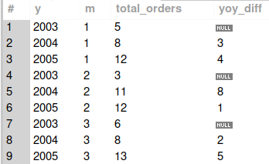

36.Using window functions, calculate the month-over-month growth in the number of products sold.

#Approach 1
with CTE_total_sales as (
select year(o.orderDate)y,month(o.orderDate)m,sum(od.quantityOrdered) as TotalOrd
from orders o
join orderdetails od
on o.orderNumber=od.orderNumber
group by y,m)
select y,m,TotalOrd-lag(TotalOrd )over(order by y,m) as mom_growth
from CTE_total_sales;

#Approach 2
SELECT t1.y,
t1.m,
t1.TotalOrd,
t1.TotalOrd - t2.TotalOrd AS mom_growth
FROM (
SELECT YEAR(o.orderDate) AS y,
MONTH(o.orderDate) AS m,
SUM(od.quantityOrdered) AS TotalOrd
FROM orders o
JOIN orderdetails od
ON o.orderNumber = od.orderNumber
GROUP BY y, m
) t1
LEFT JOIN (
SELECT YEAR(o.orderDate) AS y,
MONTH(o.orderDate) AS m,
SUM(od.quantityOrdered) AS TotalOrd
FROM orders o
JOIN orderdetails od
ON o.orderNumber = od.orderNumber
GROUP BY y, m
) t2
ON (t1.y = t2.y AND t1.m = t2.m + 1)
OR (t1.y = t2.y + 1 AND t1.m = 1 AND t2.m = 12)
ORDER BY t1.y, t1.m;

Explanation:
Approach 1:
This query calculates monthly product quantities in a CTE.
It uses LAG() to compute month-over-month growth.
Approach 2:
This query joins monthly totals with the previous month’s totals.
It manually calculates MoM growth using join conditions.
Output:

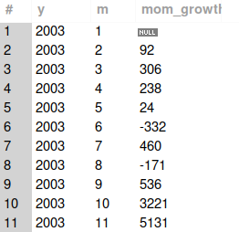

37. Rank the offices based on the total number of orders processed.

#Approach 1
SELECT e.officeCode,
COUNT(o.orderNumber) AS total_orders,
DENSE_RANK() OVER (ORDER BY COUNT(o.orderNumber) DESC) AS office_rank
FROM employees e
JOIN customers c ON e.employeeNumber = c.salesRepEmployeeNumber
JOIN orders o ON c.customerNumber = o.customerNumber
GROUP BY e.officeCode;

#Approach 2
SELECT t1.officeCode,
t1.total_orders,
(
SELECT COUNT(DISTINCT t2.total_orders)
FROM (
SELECT e.officeCode,
COUNT(o.orderNumber) AS total_orders
FROM employees e
JOIN customers c ON e.employeeNumber = c.salesRepEmployeeNumber
JOIN orders o ON c.customerNumber = o.customerNumber
GROUP BY e.officeCode
) t2
WHERE t2.total_orders > t1.total_orders
) + 1 AS office_rank
FROM (
SELECT e.officeCode,
COUNT(o.orderNumber) AS total_orders
FROM employees e
JOIN customers c ON e.employeeNumber = c.salesRepEmployeeNumber
JOIN orders o ON c.customerNumber = o.customerNumber
GROUP BY e.officeCode
) t1;

Explanation:
Approach 1 (Using DENSE_RANK):
This query counts total orders per office and ranks them using DENSE_RANK().
Offices with equal totals share the same rank.
Approach 2 (Manual Ranking):
This query calculates rank by counting distinct higher totals.
It assigns rank dynamically without window functions.

Output:
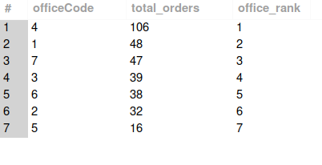

38. Identify the employees with sales below the average sales of their office.

WITH emp_sales AS (
SELECT e.officeCode,
e.employeeNumber,
SUM(od.quantityOrdered * od.priceEach) AS total_sales
FROM employees e
JOIN customers c ON e.employeeNumber = c.salesRepEmployeeNumber
JOIN orders o ON c.customerNumber = o.customerNumber
JOIN orderdetails od ON o.orderNumber = od.orderNumber
GROUP BY e.officeCode, e.employeeNumber
)

SELECT *
FROM emp_sales e1
WHERE total_sales < (
SELECT AVG(total_sales)
FROM emp_sales
WHERE officeCode = e1.officeCode
);

#Approach 2

SELECT *
FROM (
SELECT e.officeCode,
e.employeeNumber,
SUM(od.quantityOrdered * od.priceEach) AS total_sales,
AVG(SUM(od.quantityOrdered * od.priceEach))
OVER (PARTITION BY e.officeCode) AS office_avg
FROM employees e
JOIN customers c ON e.employeeNumber = c.salesRepEmployeeNumber
JOIN orders o ON c.customerNumber = o.customerNumber
JOIN orderdetails od ON o.orderNumber = od.orderNumber
GROUP BY e.officeCode, e.employeeNumber
) t
WHERE total_sales < office_avg;

Explanation:
Approach 1 (Using CTE):
This query calculates employee sales in a CTE.
It compares each employee’s sales to their office’s average.
Approach 2 (Using Window Function):
This query calculates office average using AVG() OVER.
It filters employees whose sales are below the calculated average.
Output:
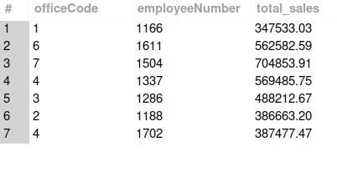
39.Calculate the percentage of total sales contributed by each product scale.

#Approach 1
SELECT p.productScale,
SUM(od.quantityOrdered * od.priceEach) AS scale_sales,
ROUND(
SUM(od.quantityOrdered * od.priceEach)
/ SUM(SUM(od.quantityOrdered * od.priceEach)) OVER () * 100,
2
) AS percent_contribution
FROM products p
JOIN orderdetails od ON p.productCode = od.productCode
GROUP BY p.productScale;

#Approach 2
SELECT t.productScale,
t.scale_sales,
ROUND(t.scale_sales / total.total_sales * 100, 2) AS percent_contribution
FROM (
SELECT p.productScale,
SUM(od.quantityOrdered * od.priceEach) AS scale_sales
FROM products p
JOIN orderdetails od ON p.productCode = od.productCode
GROUP BY p.productScale
) t
CROSS JOIN (
SELECT SUM(od.quantityOrdered * od.priceEach) AS total_sales
FROM products p
JOIN orderdetails od ON p.productCode = od.productCode
) total;

Explanation:
Approach 1 (Using Window Function):
This query calculates total sales per scale and divides by overall sales using a window function.
It computes the percentage contribution directly.
Approach 2 (Using CROSS JOIN):
This query calculates scale sales in a subquery.
It cross joins with total sales to compute percentage contribution.
Output:
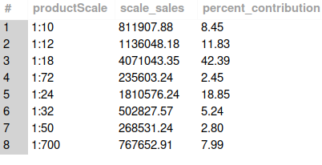

40.Using a subquery, list all employees who have processed orders worth over $500,000.

#Approach 1
select emp_Number,Emp_FName,Emp_LName,sales
from
(
select e.employeeNumber as emp_Number,e.firstName as Emp_FName,e.lastName as Emp_LName,sum(od.quantityOrdered*od.priceEach) as sales
from employees e
join
customers c
on e.employeeNumber = c.salesRepEmployeeNumber
join
orders o
on c.customerNumber = o.customerNumber
join orderdetails od
on o.orderNumber = od.orderNumber
group by e.employeeNumber,e.firstName) k
where sales>500000;

#Approach 2
SELECT e.employeeNumber,
e.firstName,
e.lastName
FROM employees e
WHERE e.employeeNumber IN (
SELECT c.salesRepEmployeeNumber
FROM customers c
JOIN orders o ON c.customerNumber = o.customerNumber
JOIN orderdetails od ON o.orderNumber = od.orderNumber
GROUP BY c.salesRepEmployeeNumber
HAVING SUM(od.quantityOrdered * od.priceEach) > 500000
);

Explanation:
Approach 1:
This query calculates total sales per employee in a subquery.
It filters employees whose total sales exceed 500,000.
Approach 2:
This query uses IN with a grouped subquery to identify employees exceeding 500,000 in sales.
It returns employee details matching that condition.
Output:
